

SIMATS ENGINEERING

Saveetha Institute of Medical and Technical Sciences Chennai- 602105
Student Name: DHANUHSYA RB Reg. No.:192565033
Course Code: CSA0974 Slot: C
Course Name: Programming In Java for Event Handling
Course Faculty: Dr. A. MOHAN & DR. E. MEGANATHAN

Project Title: Trust Scan QR: Intelligent Java-Based System for Detecting Malicious QR Codes with Risk Scoring and URL Analysis
Module Photographs:
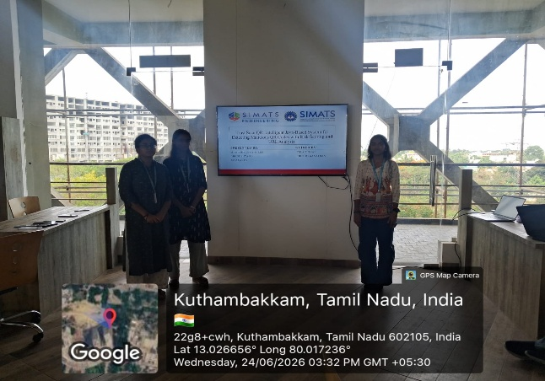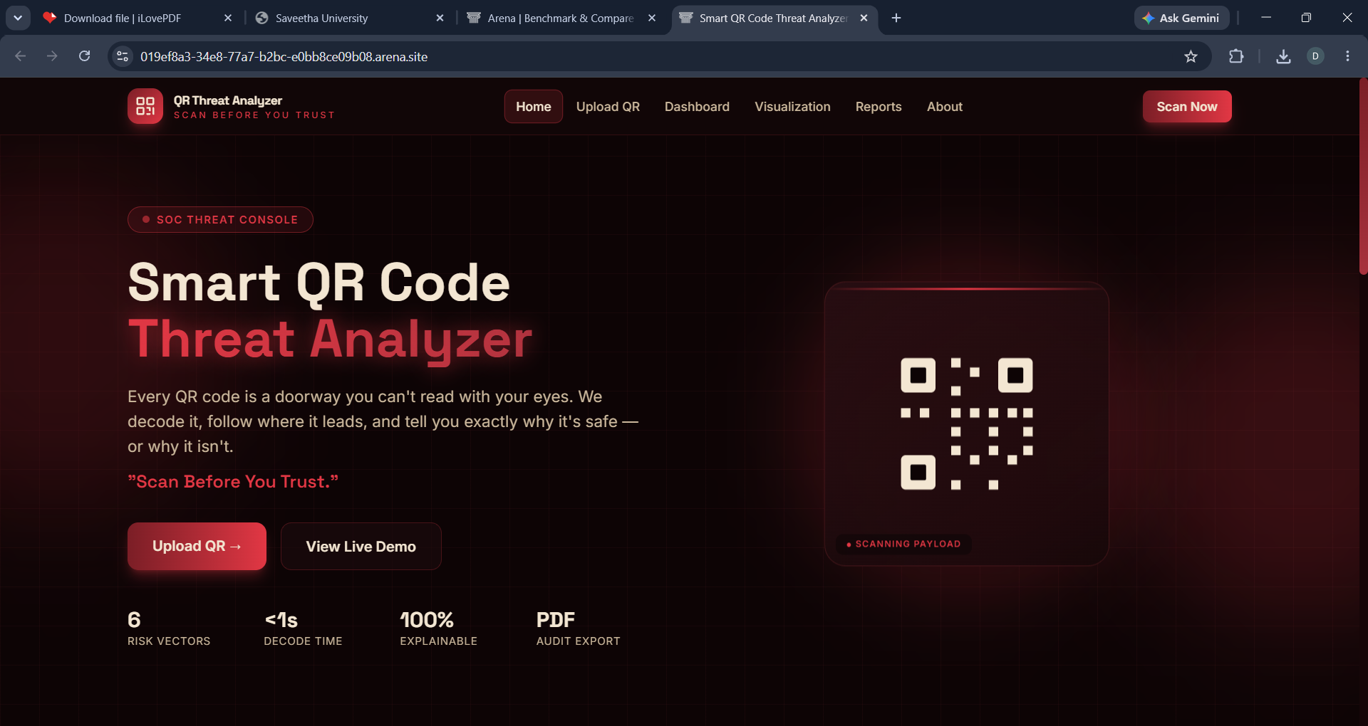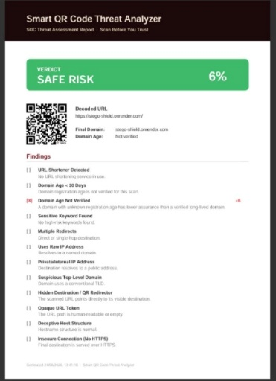
Project Description:
The Smart QR Code Threat Analyzer is a Java-based cybersecurity application developed to identify malicious QR codes before users access their embedded content. The system accepts a QR code image uploaded by the user and decodes it to extract the encoded information, such as a URL, email address, phone number, or plain text. Once the QR content is extracted, it undergoes multiple security checks to detect potential threats. The analyzer validates URLs, identifies suspicious domains, checks for insecure protocols (HTTP), detects shortened links, and searches for phishing or malicious keywords. Based on these security rules, the application calculates a threat score and classifies the QR code as Safe, Suspicious, or Malicious.
The backend is developed using Java Spring Boot, providing REST APIs for QR decoding and threat analysis. The system uses exception handling to manage invalid or unreadable QR codes and ensures reliable processing. Its modular architecture separates QR decoding, threat analysis, and response generation, making the application easy to maintain and extend. The analyzer provides users with a detailed security report, including detected risks and recommendations before opening the QR content. This project helps improve cybersecurity awareness by preventing phishing attacks and malicious QR code exploitation. It demonstrates the practical application of Java programming, RESTful web services, secure coding practices, and rule-based threat detection in a real-world cybersecurity solution.

Student Signature Guide Signature

